**Handbook of Accreditation**

**For the Government of India Schemes of Skill Development in ESDM Sector**



## Detailed Guidelines cum Application Form for Accreditation of Training Partners for the Implementation of Skill Development Scheme in Electronics System Design and Manufacturing (ESDM) Sector for Jharkhand

**NIELIT Ranchi**

An Autonomous Scientific Society of

Ministry of Electronics and Information Technology (MeitY), Government of India

2nd Floor, RIADA Bhawan, Main Road, Ranchi-834001

Web: <http://nielit.gov.in/ranchi/>

Contents

1. Preamble 3
2. Schedule 3
3. Objectives 3
4. Salient Features of the Scheme 3
5. Level-wise Eligibility, Remaining Targets & Fees 4
6. Invitation for Accreditation of Training Partner: 7
7. Who Can Apply for Accreditation 7
8. Type of Accreditation 7
9. Requirements and eligibility of the Institutions 8
10. Procedure for ESDM Accreditation: Class A & Class B 10
11. Key Responsibilities of an Accredited Institute 12
12. Other Terms and Conditions 14
13. Guidelines for submission 16

|  |  |  |
| --- | --- | --- |
| ANNEXURE-I | Details of Training to be provided under ESDM Scheme | 17 |
| ANNEXURE-II | Covering Letter Format | 20 |
| ANNEXURE-III | Format for applying ESDM accreditation | 21 |
| ANNEXURE-IV | Application Performa for Accreditation of Training | 23 |
| ANNEXURE-V | Institutes for ESDM Scheme  Undertaking / Code of Ethics by Training Partner on its Letter Head | 25 |

2

# Preamble:

NIELIT is an Autonomous Scientific Society of Ministry of Electronics and Information Technology (MeitY), Govt. of India. NIELIT, Ranchi offers various training programs aimed at skill-upgradation and capacity building in the emerging area of Electronics and Information Technology. Since inception, NIELIT Ranchi has been playing an important role in offering many courses in the area of digital literacy like CCC (Course on Computer Concept), BCC (Basic Computer Course) and ACC (Awareness in Computer Concepts). Furthermore, NIELIT, Ranchi also offer numerous courses in the area of non formal sector like NIELIT 'O' level and CHM 'O' level. It has also organized various free training programmes for different candidates under different Government Schemes from time to time.

The Government of India launched the 'Scheme for Financial Assistance to Select States for Skill Development in ESDM Sector' in November 2013. The scheme was aimed at enhancing the skilling capacities in ESDM (Electronics System Design and Manufacturing) Sector through public and private sector for students/unemployed youth belonging to other disciplines. The details of the scheme are available on ESDM por[tal http://esdm-skill.deity.gov.in](http://esdm-skill.deity.gov.in/) .

The purpose of this document is to invite applications for accrediting Training Partners in the state of Jharkhand for the implementation of Skill Development Schemes in Electronics System Design and Manufacturing (ESDM) sector funded by Ministry of Electronics and Information Technology (MeitY), Govt. of India.

# Schedule:

Application forms received for becoming Training Partner (TP) till the last day of every month will be scrutinized in first week of subsequent month

# Objectives:

Initially the objective of the scheme was to provide financial assistance to select 8 states (in phase I) for facilitating skill development for 90,000 persons in ESDM sector for improving their employability.

Subsequently in December 2014, the Government of India enhanced the scope of the scheme (with minor variations in fund flow) to the rest of the country. The new scheme envisaged as **'Scheme for Skill Development in ESDM for Digital India**' aims to skill 3,28,000 candidates. Both the schemes will run concurrently and set a cumulative target of training 4,18,000 candidates till 31st March 2020 for gainful employment in ESDM Sector. The list of courses offered is given in **Annexure I. (The List of courses will be updated from time to time as per Scheme).**

# Salient Features of the Scheme:

* 1. Target Beneficiaries - 8th /10th Pass, ITI Diploma holders, Polytechnics, Under Graduates, and Graduates.
  2. Training being imparted in 5 levels i.e. NSQF Compliant Level-1 to Level-5.
  3. There are three Key Implementing Agencies (KIAs) to implement the Scheme. These are National Institute of Electronics & Information Technology (NIELIT), Electronics Sector Skill Council of India (ESSCI) and Telecom Sector Skill Council (TSSC).
  4. Scheme Parameters (Hours, Base Cost etc.) are aligned to Common Norms notified by Cabinet for various Skill Development Schemes.
  5. Financial Assistance for Skilling and Certification is 75% to General Category and 100% to SC

/ ST/EWS Category

* 1. An Expert Committee has recommended 59 NSQF Compliant courses (40 Services and 19 Manufacturing Courses.)

# Level-wise Eligibility, Remaining Targets & Fees:

|  |  |  |  |  |
| --- | --- | --- | --- | --- |
|  | **Lower level skills** | | **Middle level**  **skills** | **Higher level**  **skills** |
| Level | Un-skilled (L1-L2) | Semi-skilled (L3) | Supervisor (L4) | Master technician  Trainer (L5)/ |
| Equivalence | IX-X std. | ITI | Diploma | Post-Diploma |
| Entry at | 8th pass | 10th pass | 10th + ITI,  12th pass,  Other graduates  (non-Science | Diploma, BSc., B.Tech |
| Course duration | 3 months  200 hrs | 6 month  300 hrs | 6 month  350 hrs | 6 month  400 hrs |
| Remaining Seats in Scheme-II in Medium States (including  Ranchi) | 19392 | 15268 | 21834 | 11257 |
| *Remaining seats will be distributed by PMU to accredited centres of three KIA i.e. NIELIT,  TSSC and ESSCI | | | | |

**The Fee details applicable to batches starting on or after 01-Apr-2018 are as below:**

**Applicable to the batches starting on or After 01 Apr 2018** Reimbursement of Course fee: 80% on Certification and 20% on Placement

|  |  |  |  |  |
| --- | --- | --- | --- | --- |
| **Level** | **L1-L2** | **L3** | **L4** | **L5** |
| **Upper Ceiling in Course Hours for re-imbursement of Fee** | **200 hrs** | **300 hrs** | **350 hrs** | **400 hrs** |
| **Course Fees** | The base cost for Service Sector is **₹**.41.90 per hour and the base cost for Manufacturing Sector is **₹**.48.90 per hour. Actual duration of course is as per the NSQF course list | | | |
| **Manufacturing Sector Courses ( ₹.)\*** | **9780** | **14670** | **17115** | **19560** |
| **Service Sector Courses (₹.)\*** | **8380** | **12570** | **14665** | **16760** |
| **Registration cum Certification Fee ( RCCF (₹.))** | **762** | **1210** | **1815** | **1905** |

*The course fee payable for per hour of training on actual hours of training with a ceiling of number of hours as above

* L1-L2 courses would be taken up only on need basis
* In order to boost Manufacturing Sector Skilling, Engineering Graduates are now permitted for L5 level courses.
* *The course fee payable for per hour of training on actual hours of training with a ceiling of number of hours as stated at pre page.
* The above fee is applicable to the batches starting on or After 01 Apr 2018 (Reimbursement of Course fee: 80% on Certification and 20% on Placement)
  1. Course Fee:

##### General Category Candidates:

* + 75% of the Course Fee would be payable by MeitY for the successfully certified candidates belonging to General category. The Course fee would be reimbursed from the Project Management Unit (PMU) to the TP, subject to approval from respective KIA and subject to meeting the employability norms set under the Scheme.
  + For the remaining 25% of course fee, the candidate may pay to the TP upon enrolment. The TP is free to bear / share (with candidate) this cost or provide credit facility to the candidates if they so desire. MeitY would have no bearing on the mutual arrangement between the TP and the candidate in this regard.
  + Scheme provides for reimbursement of 75% of the Course Fee under 2 installments: 1st installment i.e. 80% of 75% is payable on successful certification of the candidates and the 2nd installment i.e. 20% of 75% is payable based on employment norms under the Scheme.

##### Reserved Category Candidates (SC/ ST/EWS):

* + 100% of the Course Fee would be payable by MeitY for the successfully certified candidates belonging to Reserved category. The fee would be reimbursed from the PMU to the TP, subject to approval from respective KIA and subject to meeting the employability norms set under the Scheme.
  + Scheme provides for reimbursement of 100% of the Course Fee under 2 installments: 1st installment i.e. 80% is payable on successful certification of the candidates and the 2nd installment i.e. 20% is payable based on employment norms under the Scheme.
  1. Registration-cum-certification Fee (RCCF):

##### General Category Candidates:

* + Every enrolled candidate would be required to pay for RCCF to the TPs at the time of enrolment.
  + The candidate will have to pay the prescribed RCCF to the TP for every attempt.
  + The TP should transfer the RCCF in respect of the enrolled batch to the KIAs within 5 working days of starting of the training.
  + The candidate will have to pay the prescribed RCCF to the TP for every attempt. The candidate would be eligible to obtain the refund of 100% RCCF for one time only, upon his/her successful certification and the necessary amount due to him/her would be transferred to his TP who would refund the amount to the candidate.

##### Reserved Category Candidates (SC/ ST/EWS):

* + Every enrolled candidate would be required to pay for RCCF to the TPs at the time of enrolment.
  + The candidate will have to pay the prescribed RCCF to the TP for every attempt.
  + The TP should transfer the RCCF in respect of the enrolled batch to the KIAs within 5 working days of starting of the training.
  + The candidate will have to pay the prescribed RCCF to the TP for every attempt. The candidate would be eligible to obtain the refund of 100% RCCF for one time only, upon his/her successful certification and the necessary amount due to him/her would be transferred to his TP who would refund the amount to the candidate
  + All fee is inclusive of all taxes, as and when applicable. No amount, over and above the prescribed limits at each level, as indicated in the Scheme, shall be payable by MeitY.

# Invitation for Accreditation of Training Partner:

* 1. NIELIT Ranchi invites applications from organizations/institutions to participate in Accreditation of Training Partners to conduct skill development programs as per the requirement of financing agency and NIELIT in the state of Jharkhand.
  2. Interested applicants may download the format and other documents related to Accreditation from the website [http://www.nielit.gov.in/Ranchi](http://www.nielit.gov.in/chandigarh)
  3. The applications must be addressed to The Director-in-Charge, NIELIT Ranchi and delivered at the following address :-

Director-in-Charge, NIELIT Ranchi

2nd Floor, RIADA Bhawan, Main Road, Ranchi- 834 001

1. Type of Accreditation:

**Class A:** Existing NIELIT Hardware (CHM-O/A Level) recognized institutions independently operating in Vocational Space are eligible to conduct the ESDM courses. The institute must ensure availability of infrastructure commensurate with the courses they wish to apply for. Self-certification to this effect with detailed list of infrastructure available should be submitted along with the application. Accreditation will be subject to a physical verification of premises as well as related infrastructure.

**Class B:** Existing AICTE/Central/State Government/Technical Board/Polytechnic/ITIs / NCVT and other private institutions can take up the Class B accreditation. The institutions falling under this category will be required to submit Self-Certification documents and other required statements. A sudden and uninformed visit may take place for the purpose of verification.

1. Who Can Apply for Accreditation:

Education plays a vital role in the development of any nation. Therefore, there is a premium on both quantity (increased access) and quality (relevance and excellence of academics programs offered) of higher education. Like in any other domain, the method to improve quality remains the same that is, finding and recognizing new needs and satisfying them with products and services of HIGH standards.

NIELIT ESDM accreditation is a quality assurance scheme for technical education. It is open to all AICTE/NCVT approved Institutions and those centers which are already empaneled/accredited by NIELIT and all others which provide technical education to students. The institutions have been broadly categorized into 3 categories: -

##### New institutions:

Taking into consideration the large network of technical education in the country, NIELIT will offer accreditation at two levels at par with each other.

* + - Under Class A accreditation, existing NIELIT Hardware (CHM-O/A Level) recognized Institutions will be approved for ESDM courses.
    - Under Class B accreditation, the existing AICTE/Central/State Govt./ Technical Board/Polytechnic/ITIs / NCVT approved Institutions will be approved for the ESDM courses on a self-accreditation model. Besides, under Class B accreditation, NON - NIELIT Hardware accredited Private Training Institutions or the already approved NIELIT Centers (Software – O/A/B/C Level) will be accredited for the ESDM courses they wish to take on for training the students.

##### NIELIT’s TP for ESDM whose accreditation is valid:

All institutions falling in this category will have to review the terms and conditions of the revised EOI and “Amended guidelines and process flow for implementation of schemes” available at [http://esdm-skill.deity.gov.in.](http://esdm-skill.deity.gov.in/) They can submit their acceptance in writing to Director-in-Charge, NIELIT- Ranchi mentioning their accreditation number on the letter.

##### NIELIT’s TP for ESDM whose accreditation has expired:

All institutions falling in this category will have to apply afresh and pay the fees as applicable.

# Requirements and eligibility of the Institutions:

##### Institutions should fall under any of these categories:

* + 1. NIELIT Hardware (CHM-O/A Level) accredited Institutes
    2. Institutions approved by Councils under Central Government like AICTE
    3. College/Institutes/ITIs/Polytechnics affiliated to a University set up by Central or State/ UT Government or recognized by UGC
    4. Schools/Institutes/ ITIs/Polytechnics approved by Central or State Boards of Secondary Education (or equivalent) or Boards of Technical Education or NCVT.
    5. Any other institute set up by Central or State/ UT government.
    6. Other training institutions operating in the field of Electronics.
    7. Training institutions set up by private companies to meet the skilled manpower requirement for in-house needs or for the Electronics sector.

##### Institutions should be in operation for at least last two years.

##### Institute shall be set up under one of the following:

* + 1. A Society registered under the Registration of Societies Act 1860 through the Chairman or Secretary of society or
    2. A Trust registered under the Charitable Trusts Act 1950 or any other relevant Acts through the Chairman or Secretary of the trust or
    3. A company established under Section 25 of Companies Act 1956.
    4. Central or State Government / UT Administration or by a Society or a Trust registered by them.
    5. The above bodies as mentioned in a, b, c may be a body formed under Public Private Partnership (PPP) or under Board of Trustees mode through an officer authorized by Central or State Government / UT Administration.
  1. The applicants shall not use name of the technical institution in such a way that the abbreviated form of the name of the technical institution becomes IIM/IIT/IISc/NIT/IIIT or a statuatory body such as AICTE/UGC/MHRD/GOI or NIELIT etc. The applicant shall also not use the word(s) Government, India, Indian, National, All India, All India council, Commission anywhere in the name of the technical Institution and other names as prohibited under the Emblems And Names (Prevention of Improper Use) Act, 1950. Provided that the restrictions mentioned above shall not be applicable, if the technical Institution is established by Government of India or its name is approved by the Government of India.
  2. The Institute should have ownership or lease of requisite land/building in its name.
  3. Institution should have the basic facilities like permanent structure for class rooms and laboratories.
  4. Well ventilated classrooms and laboratories of size at least 40 sq mt each, the basic amenities like drinking water, toilets (separate for men and women), well equipped labs (as per course requirements), electricity connection with power backup solutions to take care of power outages.
  5. Furniture for all the classrooms/labs/Audio-Video room/library/ staff rooms etc.
  6. Minimum Area Requirements for one batch of 25 students is as follows:

|  |  |  |  |  |  |
| --- | --- | --- | --- | --- | --- |
| **Requirement/Level** | **L 1** | **L2** | **L3** | **L4** | **L5** |
| **Classroom (approx size)** | 40 sqm | 40 sqm | 40 sqm | 40 sqm | 40 sqm |
| **Lab/workshop(approx size)** | 40 sqm | 40 sqm | 40 sqm | 40 sqm | 40 sqm |
| **Admin space** | Adequate | Adequate | Adequate | Adequate | Adequate |
| **Amenities** | Adequate | Adequate | Adequate | Adequate | Adequate |
| **Parking area** | Adequate | Adequate | Adequate | Adequate | Adequate |

* 1. Minimum Faculty Requirements for one batch of 25 students is as follows:

|  |  |  |  |  |  |
| --- | --- | --- | --- | --- | --- |
| **Minimum count of Staff required along with Qualification** | | | | | |
|  | **L 1** | **L2** | **L3** | **L4** | **L5** |
| **Faculty** | 01 B.Tech/M. Tech. or equivalent. | | 02 B.Tech/ M. Tech. or equivalent. | | |
| **Lab support**  **staff** | 1 Diploma/CHM-O/A Level/ ITI or  equivalent. | | 2 Diploma/ CHM-O/A Level /ITI or  equivalent. | | |

1. Equivalent qualification as defined by AICTE/UGC/AIU or other competent authority.
2. With increase in intake, the faculty to student ratio should not be less than 1:30.
3. Faculties must have relevant experience in the courses applied.
   1. Well-equipped library with sufficient number of books related to the courses should be maintained.
   2. The institute shall provide the following facilities for conduct of examinations:
4. PCs for the entire batch with Good Internet connectivity for conduct of Online Examination.
5. A good quality Scanner, a Laser Printer and Computer with Internet connection for examination work to the Examination Staff.
6. Two Technical manpower and all the required support for Server Setup and Lab setup etc. for Online Examination.
7. Two support staff for both Online examination and Practical Assessment.
8. Arrange Power Backup facility such as UPS, Generator for uninterrupted & smooth conduct of examination.
9. Make arrangements for Videography of the whole examination activity (continuous streaming) as and when required.
10. Provide UIDAI approved biometric devices for authentication and authorization purposes.
11. Hardware/Software/Infrastructure required for conduct of Examination

# Procedure for ESDM Accreditation: Class A & Class B

* 1. The basic procedure for accreditation will include the following:

Any institute that fulfils the accreditation norms for this class, prescribed above, may apply to NIELIT using the application form and other Performa given at Annexure-II, III, IV &V. The accreditation fee structure is given on given on next page

|  |  |  |
| --- | --- | --- |
| ESDM Accreditation Registration fee: | | |
|  | For already NIELIT Accredited Centres for ESDM | ₹ NIL |
| For institutes Accredited with NIELIT for CHM O/A Level and for Government Institutions | ₹ 6000 |
| For private Institutes | ₹ 12000 |
| Course Accreditation fee: | | ₹ 2000/- per course per annum |
| Institute Inspection fee: | | ₹ 10000/- |

*(e.g. 1. For* institutes Accredited with NIELIT for CHM O/A Level and for Government Institutions *to one course for two years, the fee would be ₹.20000/- plus taxes. 2. Similarly for a private institute to run one course for two years, the fee would be ₹.26000/- plus taxes)*

###### Note:

1. *All the payment should be made by Demand Draft in favour of* “National *Institute of Electronics and Information Technology*” payable at Ranchi.
2. *GST and other Taxes as applicable from time to time will be extra and should be paid along with requisite fees. Presently GST @18% is applicable.*
   1. Applicant must submit Self Certification in form of Affidavit on Non Judicial Stamp Paper duly notarized, supporting documents for classifying them as Class A/ Class B, Govt. technical institution, institute setup documents (Certificate of Registration), Documents relating to Financial Position (Copies of balance sheets of at least last 2 years certified/audited by CA), copy of PAN and GST registration etc.
   2. All the pages of this handbook, Guidelines and Process flow document of the scheme, supporting documents must be numbered, signed and stamped by the owner of the institute and should be submitted along with the application and requisite fees in form of demand draft.
   3. After receiving the applications for accreditations, a preliminary screening will be done to ensure eligibility for accreditation and necessary documents attached.
   4. All the applications will be scrutinized by a committee constituted by the Director-in-Charge, NIELIT Ranchi for ESDM Courses according to the laid down criteria for accreditation.
   5. The eligible institutions will be inspected by Inspection Committee. ESDM accreditation number will be issued to the institute after approval of the recommendations of Inspection Committee by the competent authority.
   6. Any institute, if not found suitable after inspection by the Inspection Committee, will be given the chance to improve in lacking area as mentioned by Inspection Committee within One

Week Time. If institute fails to do so within one week, its application for accreditation will be cancelled and payment made by the institute would be forfeited. However, for all such cases the concerned institute has to pay inspection fees again.

* 1. Even after the 2nd inspection, if the institute is not fulfilling the norms of course accreditation, the application of the institute would be rejected & all fee will be forfeited. Such institute shall not be allowed for fresh application for one year.
  2. The Inspection Committee will submit its report and recommendations to the Director-in-Charge, NIELIT Ranchi.
  3. The recommendations of the Inspection Committee will be considered by the Director-in-Charge, NIELIT Ranchi and if found appropriate, provisional accreditation would be granted to the applicant institution.
  4. After provisional accreditation, the institution will be granted 'ESDM Training Partner ID' which will be used in all future correspondence. After accreditation, TP must maintain the required infrastructure to conduct the training and examination for the particular course. Any deviation noticed in this regard may result in cancellation of accreditation and batches at the centre.
  5. Once provisional accreditation is granted either in Class-A or in Class-B, the institution is required to enter into a Memorandum of Understanding (MoU) with NIELIT Ranchi. The MoU will list out the terms & conditions for implementation of ESDM Courses an ESDM Accredited Institute for NIELIT.
  6. Accreditation would be for two years from the date of Accreditation. Institutes will have to apply for renewal of ESDM Accreditation one month before the expiry of existing ESDM Accreditation with inspection fee and course accreditation fees. NIELIT, Ranchi can consider the request subject to continuation of the scheme after 31-03-2020.

# Key Responsibilities of an Accredited Institute:

* 1. An accredited institute can initiate admission process and classes for the validated ESDM Courses in consultation with NIELIT and State Implementing Agency(SIA). TPs shall be responsible for mobilization of students.
  2. The accredited institutes are expected to closely follow the guidelines set by MeitY for the ESDM Scheme and subsequent Orders & Amendments issued in each case in connection with the scheme.
  3. As per the Notification of ESDM Scheme, 70% placement of candidates is an important part of the scheme. Hence, the interaction with the concerned industries in the local areas is very

important for the placement of the pass outs. The TPs are expected to ensure maximum employment of their pass out candidates.

* 1. TPs will be responsible for Entering and Maintaining the data/information of students for examination and certification on the ESDM skill development portal. They will also provide the same in other format as required by MeitY/NIELIT/SIA from time to time.
  2. Placement details have to be mandatorily entered on the ESDM Skill Development Portal after placement of the candidate. TPs will also provide the supporting documents whenever required by MeitY/NIELIT/SIA.
  3. The subsequent admissions and reimbursements of grants, if any, would be dependent upon the placement of the candidates.
  4. To conduct free and fair examinations as and when assigned. TP will make all arrangements (stationery, lab facilities, infrastructure setup, etc) for the Assessor to conduct the assessment.
  5. TP will be responsible for scheduling assessment of the candidates with the KIAs, so that the examinations are conducted by KIA within 2 weeks from date of completion of Training.
  6. TP will follow the procedure for allotment of batches (Seat Allotment Mechanism), enrollment, conduct of training, assessment, etc as laid down by MeitY and NIELIT from time to time for smooth implementation of scheme.
  7. TP shall put in personal efforts to invite students for the ESDM skill development courses. TP shall select the candidates to be trained from the list of applicants as per the reservation guidelines set for the same.
  8. The TP shall provide space and infrastructure for training facility.
  9. TP shall provide lab facility including required equipment for training for the courses in which interest has been shown through this application.
  10. TP shall provide classroom to accommodate at least 25 Trainees with required infrastructure.
  11. TP shall provide required trained faculty as per the requirement of the course and guidelines in the instructions from MeitY and NIELIT.
  12. TP shall ensure one placement officer to be nominated for coordinating with Industry.
  13. TP shall also provide required space for office room, Faculty room/ Library, Purified drinking water and wash rooms for use of faculty members and students (separate for Ladies & Gents).
  14. Supporting Staff, Sweeper/ Cleaners/ MTS and Local Management services shall be provided.
  15. Standby power arrangement shall be provided for smooth conduct of training and examinations.
  16. High Speed Internet Facility to be provided for smooth conduction of training and examination.

# Other Terms and Conditions:

* 1. TP should approach the concerned Electronic industry for placement of candidates for a particular course. A recommendation letter from at least one electronic industry is mandatory before an order is issued to the TP for conduct of training. Recommendation letter must include the commitment of placement of successful candidates for a particular batch and particular course. TP can send recommendation letter at the time of submission of application.
  2. TP shall not start any training without receipt of formal order from NIELIT.
  3. TP shall start training programme within one month of date of issue of order for a particular batch or as stipulated in the instructions time to time from MeitY/NIELIT. In case, training is not started within one month of issue of order or as directed by MeitY/NIELIT, then order may be cancelled and batch may be allotted to other participating institute.
  4. The complete infrastructure like classroom, Lab for Training Modules, Projector, Audio/Visual training aids etc. required for training will be provided by TP. A certificate of the availability of infrastructure and its details shall be provided as and when desired by NIELIT.
  5. TP will ensure admission of the candidates through proper counselling of the candidates. The target given in order has to be met by the TP. It is responsibility of the TP that target is achieved in terms of admitted candidates and passing the examination conducted by NIELIT.
  6. TP will tie up with relevant Industries for providing employment opportunities to the trainees.
  7. A database of the trainees will be maintained by TP along with UID (Aadhar Number). Aadhar Number is mandatory for registration of the candidate. This information shall be furnished to NIELIT, Ranchi from time to time.
  8. The training program shall be conducted as per syllabus designed and developed by NIELIT and approved by MeitY.
  9. NIELIT Ranchi reserves its right to update the training program by adding new courses or modifying existing courses.
  10. Fees as prescribed shall be collected against receipt from general candidates by the TP. TP is not allowed to charge any course fee from candidates of SC/ST/EWS category. TP is free to bear/share (with candidate) fees or provide credit facility to the general candidate if they so desire. NIELIT has no role on the mutual arrangement between the TP and the candidate in this regard.
  11. TP shall take the attendance of trainees on physical register and Biometric machine both. 80% attendance is mandatory for candidates to appear in examination. Month wise report shall be sent by TP, along with feedback of students to NIELIT, Ranchi.
  12. TP shall make a time-table for a particular batch. Copy of the same shall be sent to NIELIT Ranchi.
  13. NIELIT Ranchi shall be entitled to evaluate the performance of the students and facilities available at the TP site from time to time and shall also have the right to demand correction/up gradation if any degradation of standard norms prescribed are noticed during such evaluation. NIELIT Ranchi shall be allowed to inspect the institute any time.
  14. At the end of the course, examination shall be conducted by NIELIT.
  15. NIELIT shall award certificates to all successful candidates.
  16. TP will ensure placement of 70% of successful candidates. This will be treated as major performance criterion for release of payment and allotment of future batches.
  17. An Agreement will be signed with TP for the implementation of training and certification scheme in Electronics System Design and Manufacturing (ESDM) sector funded by Ministry of Electronics and Information Technology, Govt. of India. Terms of the Agreement will be as per details given in this application. However, NIELIT may alter/modify the terms and conditions as per requirement of successful & timely completion of work.
  18. The Director-in-Charge, NIELIT Ranchi reserves the right to accept/reject any or all application without assigning any reason and also will not be responsible for postal delays.
  19. TP shall obey the instruction issued by MeitY and NIELIT from time to time.
  20. Each page of application must be signed and stamped by authorized signatory. Affidavit of authorized signatory must be submitted along with.

# Guidelines for submission:

The following conditions should be observed while submitting the application for Empanelment of Training Institutes in ESDM Sector:

* 1. The application should be submitted as Annexure-II (covering Letter) & Annexure-III, IV & V. The institute should seal the application documents in sealed envelope duly super scribed as **“Application for Empanelment of Training Institutes in ESDM Sector”.**
  2. Applicant must submit Self Certification in form of Affidavit on Non Judicial Stamp Paper duly notarized, supporting documents for classifying them as Class A/ Class B, Govt. technical institution, institute setup documents (Certificate of Registration), Documents relating to Financial Position (Copies of balance sheets of at least last 2 years certified/audited by CA), copy of PAN and GST registration etc.
  3. All the pages of this handbook, Guidelines and Process flow document of the scheme, supporting documents must be numbered, signed and stamped by the owner of the institute and should be submitted along with the application and requisite fees in form of demand draft.
  4. Canvassing in any form, direct or indirect, on part of agency will render the tender liable for exclusion from consideration.
  5. Incomplete application will not be considered. NIELIT Ranchi will not be responsible for any postal delays.
  6. Application forms received for becoming Training Partner till the last day of month will be scrutinized in first week of next month.
  7. Application complete in all respects, should be submitted at following address: The Director-In-Charge,

NIELIT Ranchi

2nd Floor, RIADA Bhawan, Main Road, Ranchi-834001

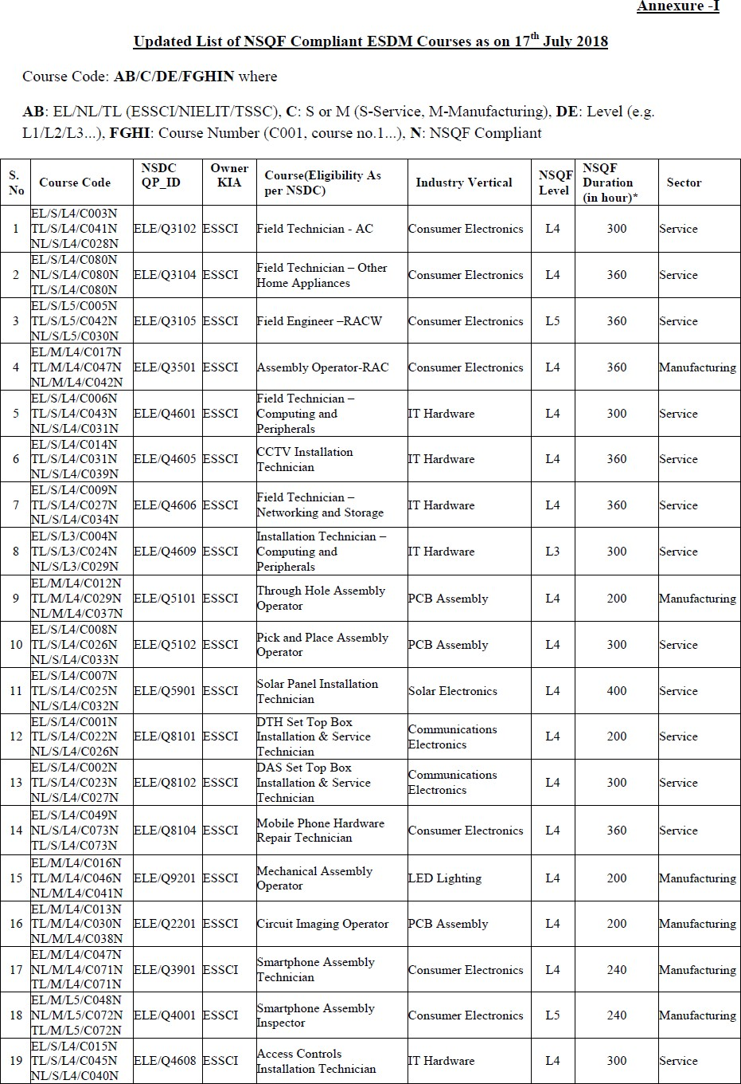

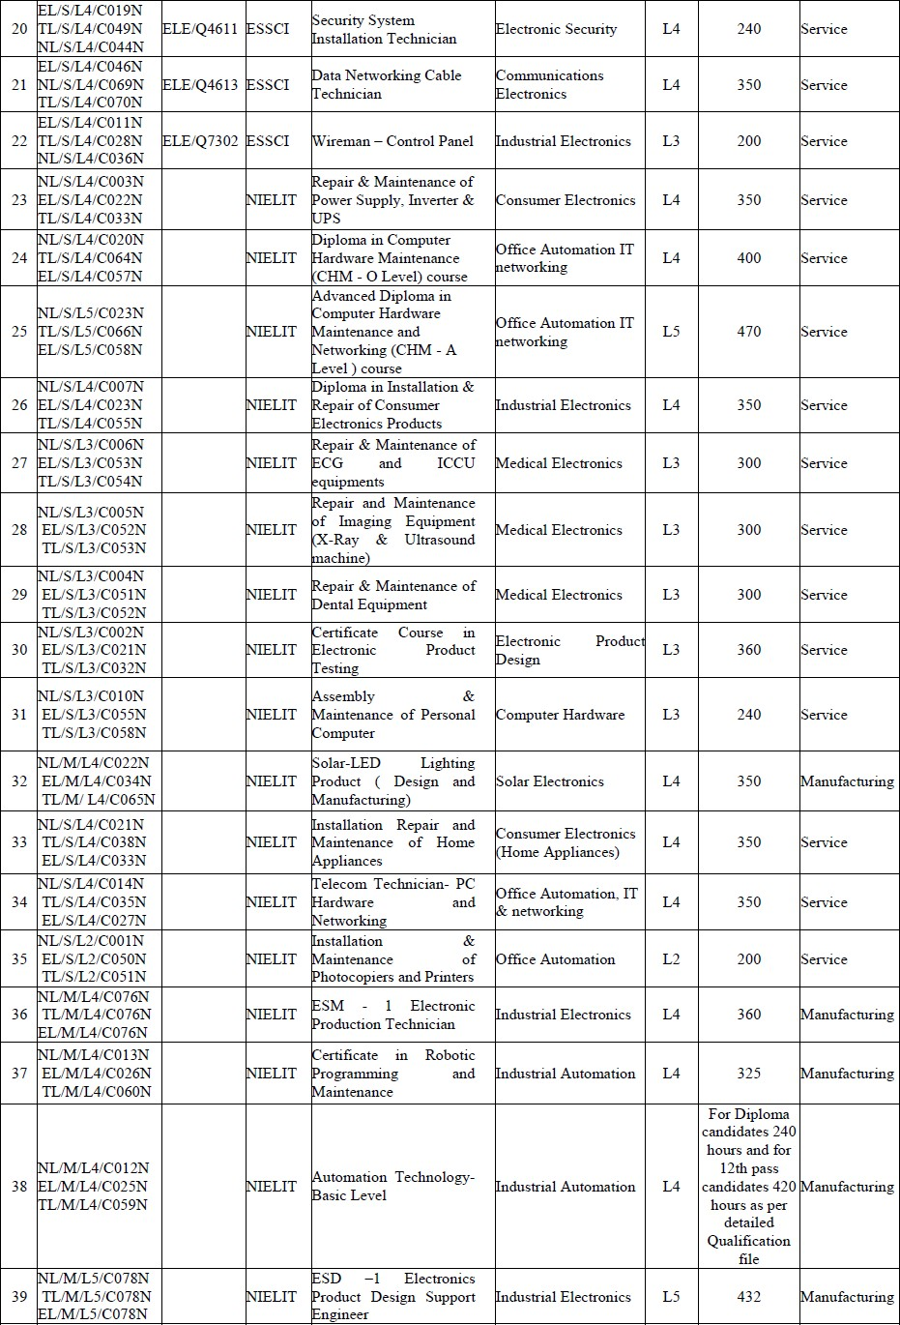

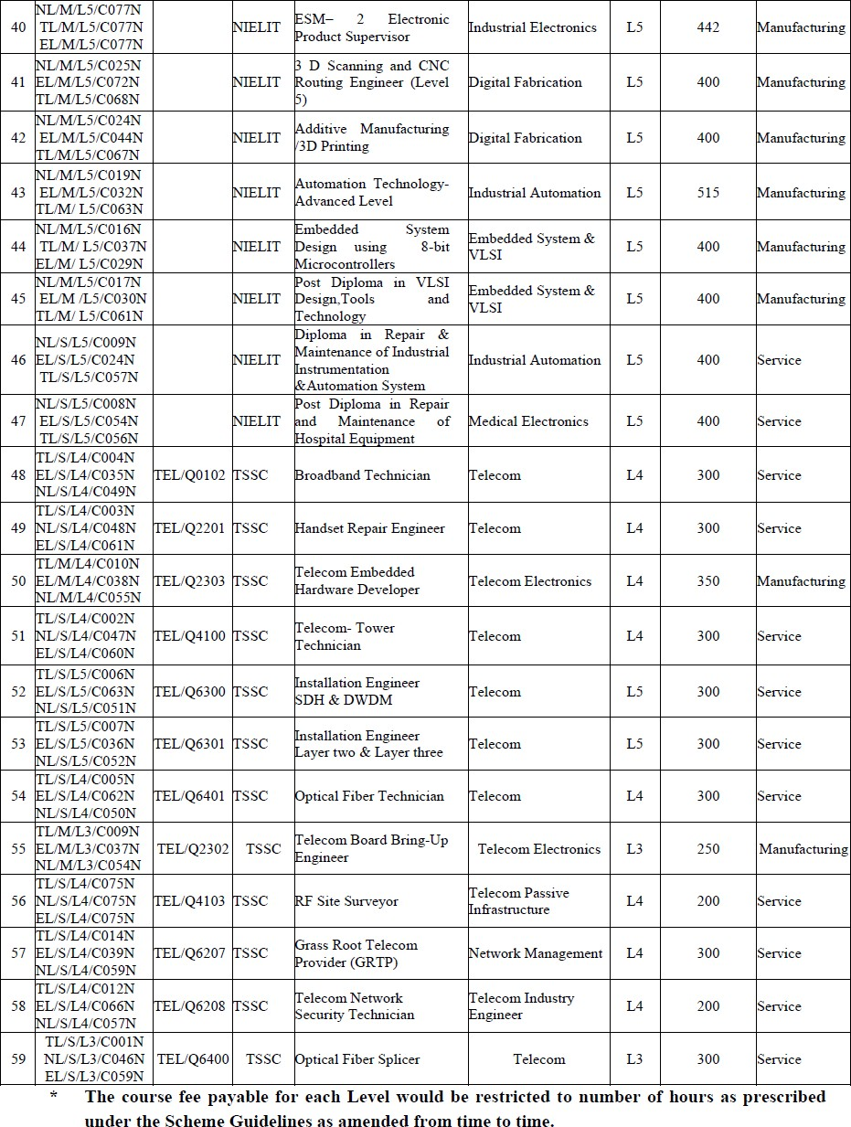

ANNEXURE-II

#### Covering Letter Format

To,

Format for covering letter (To be submitted on the Letter head of the applicant institution)

The Director-in-Charge, NIELIT Ranchi

2nd Floor, RIADA Bhawan, Main Road, Ranchi-834001

Sub: Application for Accreditation of Participating Institutes in ESDM Sector Dear Sir,

1. I/We having examined the application document, herewith submit our response to your application for accreditation of Training Institutes in ESDM Sector.
2. I/We have read the provisions of the application document and confirm that these are acceptable to us. We further declare that additional conditions, variations, deviations, if any, found in our application shall not be given effect to.
3. I/We would like to declare that we are not involved in any litigation with any Government (Central/State) in India and we are not under a declaration of ineligibility for corrupt or fraudulent practices.
4. I/We hereby declare that all the information and statements made in this application are true and accept that any misrepresentation or hiding of facts in any form contained in it may lead to our disqualification.
5. I/We understand that NIELIT Ranchi is not bound to short-list / accept any proposal received in response to this application.
6. I/We understand that Empanelment with NIELIT Ranchi does not guarantee that every /any of the applicants invited to application for becoming training Partner of NIELIT in ESDM sector, will be awarded any work order under ESDM Project.

Our correspondence details / authorized person to deal with regard to this APPLICATION is:

|  |  |  |
| --- | --- | --- |
| **S. No.** | **Information** | **Details** |
| **1.** | Name of the Contact Person |  |
| **2.** | Designation and contact address of the person to whom  all references shall be made regarding this APPLICATION |  |
| **3.** | Telephone , FAX number |  |
| **4.** | Mobile number & e mail of the Contact Person |  |

We hereby undertake that we accept all terms and conditions of the APPLICATION unconditionally.

Signature of Authorized Signatory with Seal

Place: (Name and Designation)

Date: Seal of the Institute

**National Institute of Electronics and Information Technology**

##### Annexure-III



##### To,

**FORMAT FOR APPLYING ESDM ACCREDITATION (FOR PROVISIONAL ACCREDITATION)**

**The Director-in-Charge, NIELIT Ranchi**

**2nd Floor, RIADA Bhawan, Main Road, Ranchi-834001**

**Subject : Application for ESDM PROVISIONAL ACCREDITATION**

Dear Sir,

My institute named (herein after called "the institute") is coming under Class-A /Class-B Institution as defined in clause 8 of this handbook and I am the “Organization Head” of the institute.

I have personally ensured that the institute fulfils the norms for accreditation and has run for the adequate sessions as mentioned in this document.

I wish to apply for accreditation of the following ESDM Courses:

|  |  |  |  |
| --- | --- | --- | --- |
| **S.No.** | **Name of Course\*** | **Course Code** | **Vertical** |
| 1 |  |  |  |
| 2 |  |  |  |
| 3 |  |  |  |
| 4 |  |  |  |

*- Details of Courses are available on the ESDM portal [http://esdm-skill.deity.gov.in](http://esdm-skill.deity.gov.in/) and <http://www.meity.gov.in/esdm/hrd>

Before submitting this application, I have personally ensured that my institute has adequate Building, infra- structure, support staff and faculty to undertake the course. I have also ensured that the institute has linkages with the industry for placement of the candidates after successfully completion of their training. The fee for the desired courses for **one year** is as under:

**For Class A**

NIELIT CHM-O/A level ACCR No. valid upto

**(Please provide the copy of Accreditation Letter)**

ESDM Accreditation Registration fee: ₹.6000/-

Course Accreditation fee: ₹. 4000 /- × ( courses)(02 years) ₹. /-

Institute Inspection fee: ₹. 10000/-

GST: ₹. /-

Total ₹. /-

**For Class B**

Type of Institution Government / Private

ESDM Accreditation Registration fee*:

For Already NIELIT accredited ESDM Centre ₹. NIL ( NIELIT ESDM ACCR No. valid upto ) **(Please provide the copy of Accreditation Letter)**

For Government Institutions ₹. 6000/-

For Private Institutes: ₹. 12,000/-

Course Accreditation fee: ₹. 4000/- × ( courses) )(02 years) ₹. /-

Institute Inspection fee: ₹. 10000/-

GST: ₹. /-

Total ₹. /-

*\*Please strike out whichever is not applicable.*

The non-refundable fee for processing of accreditation ₹. is enclosed in the form of Demand Draft No…………………………… dated…………………………. issued by bank in the name of "National Institute of Electronics and Information Technology” payable at Ranchi is enclosed.

**I undertake that I will not sub-franchise the training. I understand that any such activity found will be considered as non-compliance and may result in de-affiliation of the TP from participating in the ESDM Skill Development Scheme.**

I am aware that In the event of deliberate nondisclosure/misrepresentation of vital information or supplying misleading information by default/mistake/blunder may result in cancellation of accreditation or accreditation process instantly along with forfeiture of the fee deposited and possible punitive action as per the decision and discretion of Director-in-Charge, NIELIT Ranchi. Kindly, initiate the process of provision accreditation of the institute.

With regards,

Signature:

Name:

Address:

e-mail:

Phone:

Mobile Number

Seal of the Institute

##### ANNEXURE-IV

##### Application Performa for Accreditation of Training Institutes for ESDM Scheme

**(Instructions:** This is Format of Application Performa. Use separate sheet wherever required. Please attach documentary evidence of the information being provided.**)**

##### General Information:

|  |  |  |
| --- | --- | --- |
| **S. No.** | **Information** | **Details** |
| (1) | Name of The Institute |  |
| (2) | Full Address With  Phone/Fax/E-Mail |  |
| (3) | Longitude and Latitude of the Centre |  |
| (4) | Date / Year of Establishment |  |
| (5) | Legal Status / Registered Under:  (Attach Documentary Proof) |  |
| (6) | Details of Registration fees Paid | Amount: DD No:  Date:  Bank Name: |
| (7) | GST No:  (Attach Documentary Proof) |  |
| (8) | PAN No:  (Attach Documentary Proof) |  |

##### Financial Strength & Turnover for the previous three years (Attach Documentary proof certified by CA):

|  |  |  |
| --- | --- | --- |
| **S. No.** | **Financial Year** | **Total Income/Turnover (₹.) \*** |
| **1.** | **2015- 2016** |  |
| **2.** | **2016- 2017** |  |
| **3.** | **2017- 2018** |  |

##### *Attach separate sheet wherever required

##### Details of Available Trainer/ Instructor*

|  |  |  |  |
| --- | --- | --- | --- |
| **S. No.** | **Name of the Trainer/ Instructor** | **Educational**  **Qualification** | **Brief Experience** |
|  |  |  |  |
|  |  |  |  |
|  |  |  |  |

##### *Attach separate sheet wherever required

##### Tie-Up With Industry for Placement*:

|  |  |  |  |  |  |
| --- | --- | --- | --- | --- | --- |
| **S. No.** | **Name of the Industry** | **Course for which placement may be provided to successful**  **candidates** | **No of Candidates which may be placed** | **Location where candidates may be placed** | **Recommendation Letter from Industry received(Yes/No)** |
|  |  |  |  |  |  |
|  |  |  |  |  |  |
|  |  |  |  |  |  |

##### *Attach separate sheet wherever required

##### Placement History*:

|  |  |  |  |
| --- | --- | --- | --- |
| **S. No.** | **Name of the**  **Industry** | **Course for which placement has**  **been provided** | **No of Candidates which have**  **been placed** |
|  |  |  |  |
|  |  |  |  |
|  |  |  |  |

##### *Attach separate sheet wherever required

Signature of Authorized Signatory with Seal

Place:

Date: (Name and Designation)

##### Annexure-V

### Undertaking / Code of Ethics by Training Partner on its Letter Head

1. I ,

S/o, D/o, W/o Of , and R/o

certify that I am the competent authority, by virtue of the administrative and financial powers vested in me, I being the *owner /* authorized person of the institution and as such is having the authority to sign the present undertaking and bind the institution and I have read and understood the ESDM Scheme Guidelines, including the Code of Ethics and other norms/ rules as applicable from time to time and as notified in the official website of ESDM Scheme (https://esdm- skill.deity.gov.in) and I agree to abide by the same.

1. I am aware that in case any information provided by me is false or misleading, NIELIT/ PMU/ MeitY may in its sole discretion take whatever action(s) or measure(s) it deems necessary and appropriate, including withdrawal of affiliation, imposition of penalty etc.

I further understand that,

1. All local, state and national laws and regulations that apply to training institutes are required to be complied with and I/We shall not engage in any business practice or activity that could discredit or damage the image or reputation of NIELIT / PMU/ MeitY directly or indirectly.
2. NIELIT/ PMU/ MeitY shall have no liability to any Institute in respect of any cost, loss, damage, claims, demands, prosecutions, fines, penalties and / or expense suffered by any institute directly or indirectly as a result of any act, omission, representation or statement of any of the candidate(s), institute and / or organization.
3. Unauthorized use of terms like “approved / recognized by Government” or any similar expression, designed to mislead the public, will attract penal action besides any administrative action that NIELIT/ PMU/ MeitY may take, as found fit.
4. Government of India / MeitY may in its absolute discretion, modify; alter; terminate; suspend for specified periods, the Schemes for Skill Development in ESDM Sector.

I further certify that the following codes of ethics, applicable to the Education/ Training Institutions, will be compiled with and I further undertake that I shall:

* NOT advertise anything which is liable to project a false impression of status of my/our Institution;
* NOT exaggerate the contents of the courses for which affiliation has been granted to gain any unfair advantage;
* NOT guarantee benefits to students that are actually false and/or not feasible;
* NOT project price terms that are false, or misleading and has been given to gain advantage over competition;
* NOT distort any statement of Government for our own gain;
* NOT criticize action of Government/ Professional bodies or Experts connected with the ESDM Schemes directly or indirectly without proper investigation;

-NOT make statement offensive to the public; including advertisements that are against public/Government/National sentiments;

* NOT make any statement/declaration/presentation/advertisement which is of ambiguous nature and which presents a false picture in any stage/part of the ESDM schemes with regard to hardware/software and/or which is sort of omissions/additions of any kind and/or which are half–truths; and
* NOT involve in any other matter/action repugnant to the spirit of ethical practices including behavior to by/our students; unauthorized use of copyrighted software etc.

###### < Official Stamp> < Signature of Authorized Signatory>

***<Date, Place >***